**MICROSERVICES HANDS-ON SUBMISSION**

**Name: Divyansh Tiwari**

**SuperSet ID: 6394658**

**HANDS ON DOCUMENT: 2. Microservices with API gateway**

**HANDS ON : Create Eureka Discovery Server and Register Microservices**

1. **Created Eureka Discovery Server**

* **Used Spring Initializr**
* **Project: Maven**
* **Spring Boot Version: 3.3.0**
* **Dependencies: Eureka Server, Spring Boot DevTools**

1. **Opened in IntelliJ  
   Unzip and opened the folder eureka-discovery-server in IntelliJ IDEA.**
2. **Enabled Eureka Server**

*@SpringBootApplication*

*@EnableEurekaServer*

*public class EurekaDiscoveryServerApplication {*

*public static void main(String[] args) {*

*SpringApplication.run(EurekaDiscoveryServerApplication.class, args);*

*}*

*}*

**In *application.properties***

*server.port=8761*

*eureka.client.register-with-eureka=false*

*eureka.client.fetch-registry=false*

**Screenshot:** Eureka server running on port 8761 and homepage showing "No instances available"

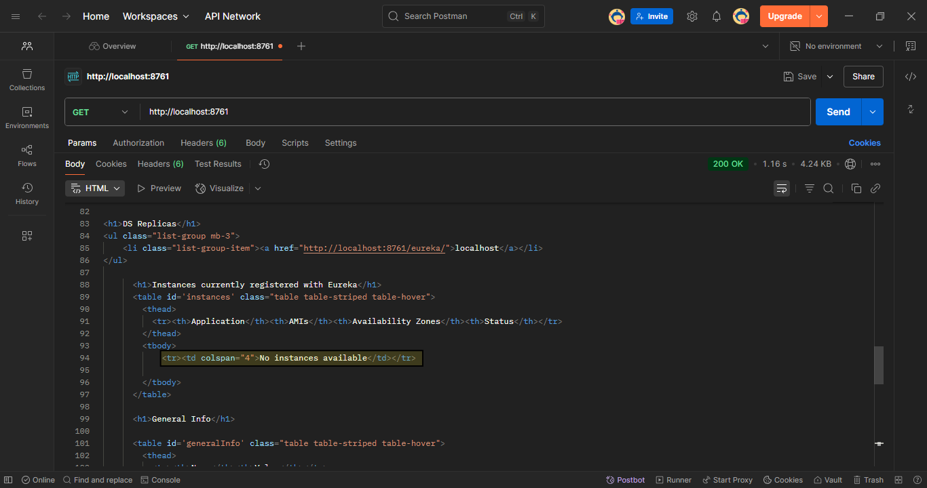

**4. Created GREET-SERVICE Microservice**

* Used Spring Initializr
* Project Name: greet-service
* Dependencies: Eureka Client, Spring Web

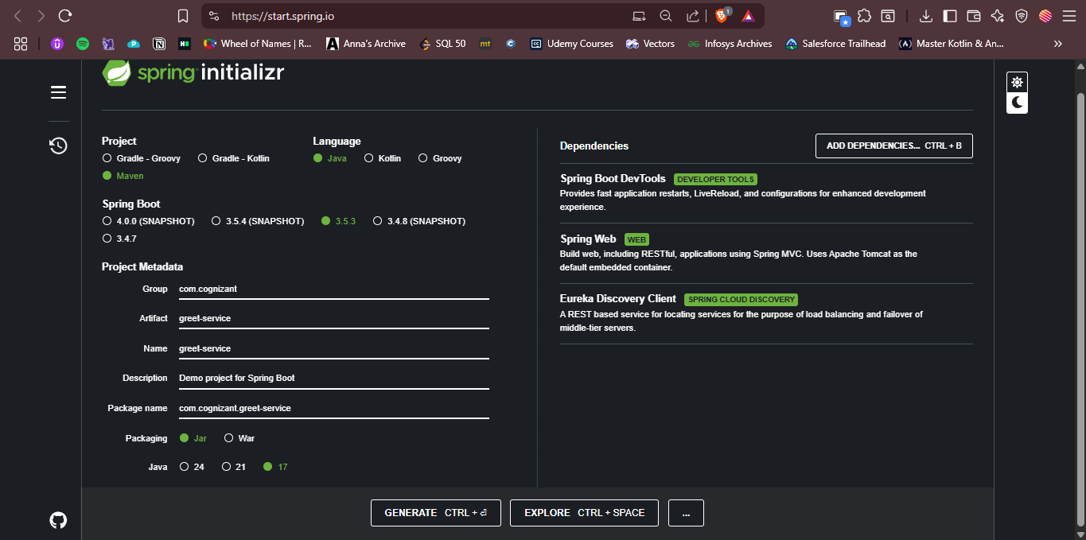

***application.properties***

*spring.application.name=GREET-SERVICE*

*server.port=8082*

*eureka.client.service-url.defaultZone=http://localhost:8761/eureka/*

**Controller Implementation**

*@RestController*

*public class GreetController {*

*@GetMapping("/greet")*

*public String sayHello() {*

*return "Hello World!";*

*}*

*}*

**Screenshot:** GREET-SERVICE running on port 8082

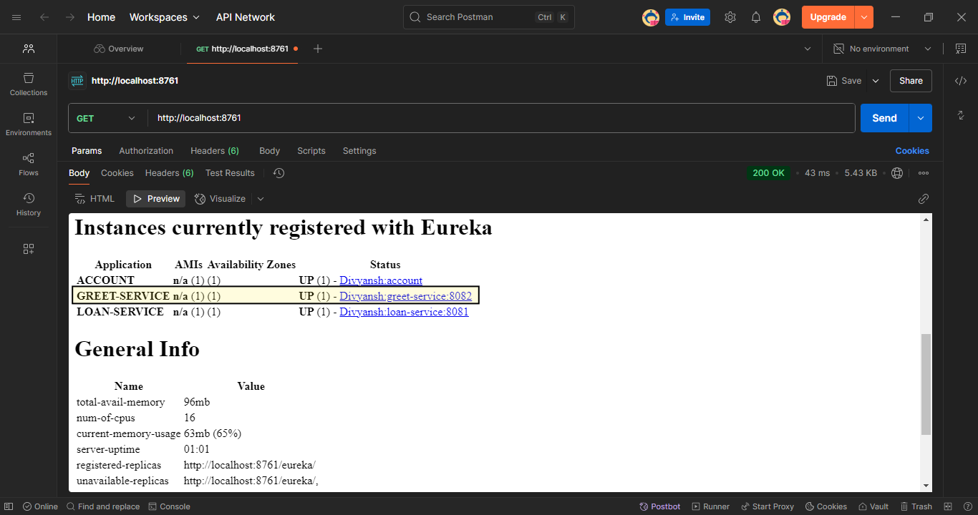

**Screenshot:** http://localhost:8082/greet returning “Hello World!”

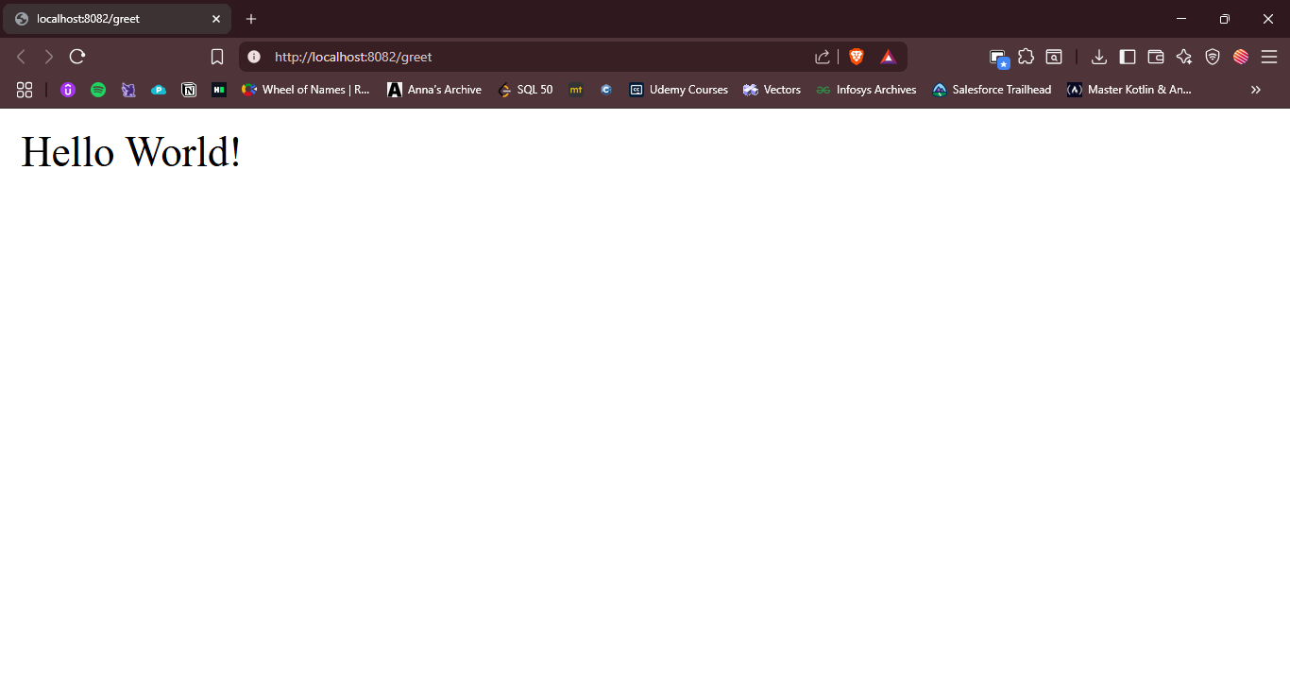

**5. Created API-GATEWAY**

* Used Spring Initializr
* Project Name: api-gateway
* Dependencies: Eureka Client, Spring Cloud Gateway

**application.properties**

*spring.application.name=API-GATEWAY*

*server.port=9090*

*eureka.client.service-url.defaultZone=http://localhost:8761/eureka/*

*spring.cloud.gateway.discovery.locator.enabled=true*

*spring.cloud.gateway.discovery.locator.lower-case-service-id=false*

**No explicit routing config is needed due to dynamic service discovery.**

**API Gateway is now running on port 9090.**

**Screenshot:** GET http://localhost:9090/GREET-SERVICE/greet in Postman returning “Hello World!”

